## Graphical Representations of Frequency Distribution

## Column diagram or Frequency bar diagram

## It is used to represent *ungrouped frequency distribution*. Two rectangular axes of co-ordinates are taken – the horizontal for the variable and the vertical for the frequency. The different values of the variable are then located as points on the horizontal axis. Next, at each of these points a perpendicular is drawn to represent the corresponding frequency.

## Column diagram.jpg

**Fig. 1:** Column diagram for the frequency distribution of number of peas in pods

**Frequency polygon**

* **For ungrouped frequency distribution:** The different values and corresponding frequencies are plotted as points on the graph paper. Two more values of the variable are taken into consideration – the value preceding the lowest value and the value following the highest value in the frequency distribution table. Both these values have zero frequency. Thus two more points are plotted. Finally, the successive points are joined by line segments to get a closed polygon.

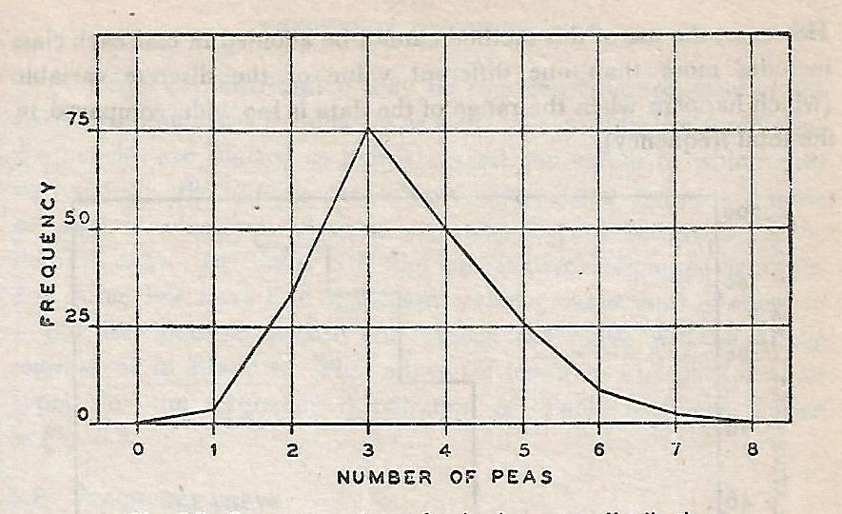

**Fig. 2:** Frequency polygon for the frequency distribution of number of peas in pods

* **For grouped frequency distribution:** A frequency polygon may also be used to represent the frequency distribution of a continuous variable, provided the classes are of equal width. The frequencies, in this case, are now plotted against the mid-points of the corresponding class-intervals and joined successively by line segment. But a better method for continuous variable is to use a histogram. To complete the polygon the point at each end immediately are joined to the lower or higher class marks (as the case may be at zero frequency) on the X-axis.

**Uses:** The frequency polygon gives an approximate idea of the shape of the frequency curve.

**Ogive or Cumulative frequency diagram**

The cumulative frequencies are plotted as points against the values to which they correspond. By joining the points, an ogive or cumulative frequency diagram is obtained. If the plotted cumulative frequencies are less-than type, it is called less-than type ogive and if the plotted cumulative frequencies are greater-than type, it is called greater-than type ogive.

It is important to note that the ogive or cumulative frequency diagram ***for a discrete variable*** will be a ***step diagram***.

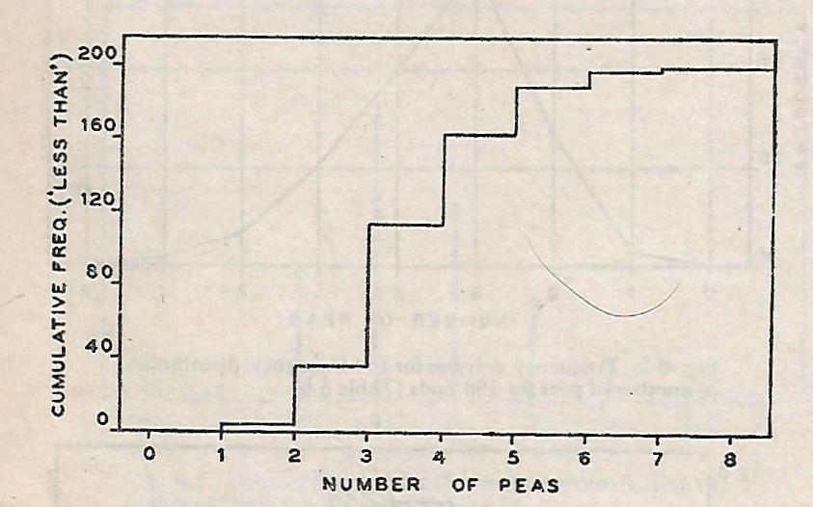

**Fig. 3**: Ogive (less-than type) for the frequency distribution of number of peas

**Uses:**

1. It is used to find the ***median, quartiles, deciles and percentiles***, or the value of the variable such that its cumulative frequency is a specified number.
2. It is also useful in finding the cumulative frequency corresponding to a given value of the variable.
3. It is also useful in finding the number of observations which are expected to lie between two given values.

**Example of Ogive for continuous variable**

**Table 6:** Frequency distribution of height for 177 Indian adult males

|  |  |  |  |  |
| --- | --- | --- | --- | --- |
| Height (cm)  Class interval | Frequency | Relative frequency | Cumulative frequency | |
| Less-than | More-than |
| 144.55-149.55 | 1 | 0.0057 | 1 | 177 |
| 149.55-154.55 | 3 | 0.0169 | 4 | 176 |
| 154.55-159.55 | 24 | 0.1356 | 28 | 173 |
| 159.55-164.55 | 58 | 0.3277 | 86 | 149 |
| 164.55-169.55 | 60 | 0.3390 | 146 | 91 |
| 169.55-174.55 | 27 | 0.1525 | 173 | 31 |
| 174.55-179.55 | 2 | 0.0113 | 175 | 4 |
| 179.55-184.55 | 2 | 0.0113 | 177 | 2 |

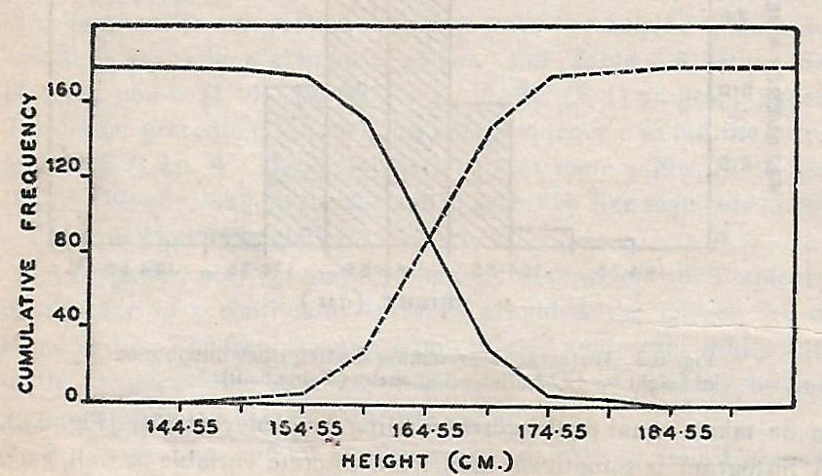

**Fig. 4**: Ogives for the frequency distribution of height of Indian adult males (Continuous lines for greater-than type and broken lines for less-than type)

**Histogram**

*A two dimensional graphical representation of* ***a continuous frequency distribution*** *is called a histogram.* On the horizontal axis the class-boundaries are located and over each class-interval a rectangle whose ***area represents the corresponding class-frequency*** is erected. Obviously, the height of a rectangle is to taken equal to the corresponding frequency-density or class frequency.

$Area of rectangle=width×height$

$=(width of class)×(frequency density)$

$=(width of class)×\frac{Class frequency}{width of class}$

$=class frequency$

It is important to note that, in histogram, the ***bars are placed continuously side by side*** with no gap between adjacent bars.

*A histogram is sometimes used for discrete variable as well, each value being regarded as the mid-point of an interval.* But its use is not recommended because in the discrete case each frequency really corresponds to a single point and not to an interval. However, the use of this method cannot be avoided in case each class includes more than one different value of the discrete variable.

**Uses:**

1. The series of rectangles in a histogram give a visual representation of the relative sizes of the various groups, and the entire distribution of total frequency among the different classes become visible.
2. The surface of the tops of rectangles gives an idea of the nature of frequency curve for the population.
3. The histogram may be used ***to find the******mode*** graphically.

**Example**: Histogram of continuous variable

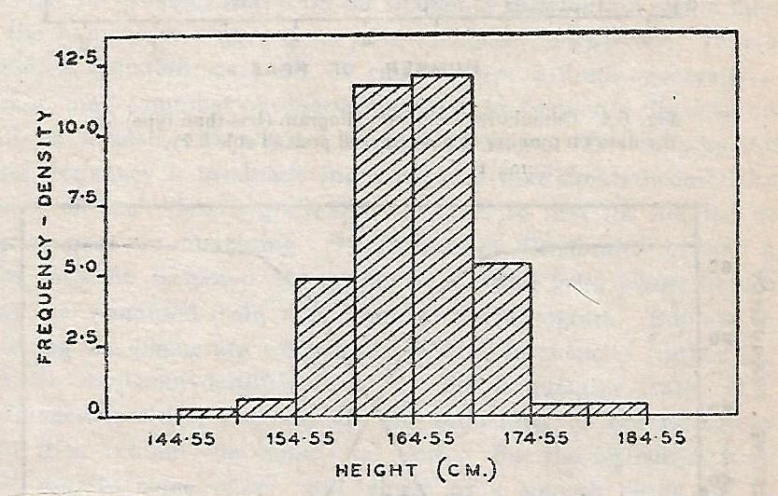

**Fig. 5**: Histogram representing the frequency distribution of height for 177 Indian adult males

**Example:** Histogram of discrete variable

**Table 7:** Frequency distribution of sales of 534 firms in an industry

|  |  |  |
| --- | --- | --- |
| Values of sale  (in crore) | Number of firms | Relative frequency |
|
| 0-500 | 3 | 0.0056 |
| 500-1000 | 42 | 0.0786 |
| 1000-1500 | 63 | 0.1180 |
| 1500-2000 | 105 | 0.1966 |
| 2000-2500 | 120 | 0.2247 |
| 2500-3000 | 99 | 0.1854 |
| 3000-3500 | 51 | 0.0955 |
| 3500-4000 | 47 | 0.0880 |
| 4000-4500 | 4 | 0.0075 |
| Total | 534 |  |

**Note:** Here the ***class-intervals are defined by class boundaries*** since upper end of a class coincides with the lower end of the next class. In such cases, ***a class-interval 500-1000 actually implies 500- less than 1000***. Therefore, a value of 1000 will fall into the next class, i.e. 1000-1500.

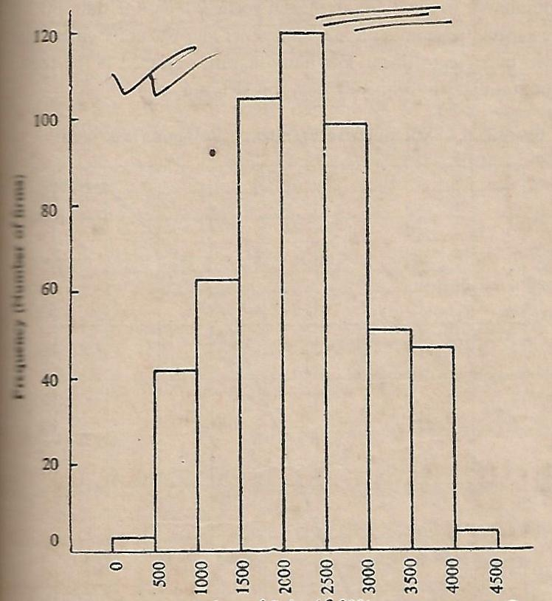

**Fig.6**: Histogram representing the frequency distribution of sales of 534 firms

**Exercises**

1. The data below give the marks secured by 70 candidates in a certain examination:

|  |  |  |  |  |  |  |  |  |  |
| --- | --- | --- | --- | --- | --- | --- | --- | --- | --- |
| 21 | 31 | 35 | 52 | 64 | 74 | 89 | 53 | 41 | 7 |
| 22 | 35 | 43 | 67 | 76 | 35 | 46 | 26 | 32 | 40 |
| 72 | 43 | 38 | 41 | 63 | 71 | 28 | 32 | 45 | 54 |
| 15 | 18 | 52 | 73 | 86 | 50 | 39 | 55 | 47 | 12 |
| 44 | 58 | 67 | 85 | 39 | 40 | 50 | 65 | 72 | 69 |
| 57 | 63 | 5 | 56 | 79 | 37 | 24 | 54 | 82 | 49 |
| 51 | 54 | 68 | 29 | 34 | 44 | 58 | 62 | 59 | 65 |

Construct a frequency distribution of the marks and draw the histogram.

1. In a sample survey of 60 workers’ families living in a factory area, the following data were obtained, as regards the number of members in the families. Form a frequency distribution and draw a frequency polygon for this distribution.

|  |  |  |  |  |  |  |  |  |  |
| --- | --- | --- | --- | --- | --- | --- | --- | --- | --- |
| 5 | 11 | 4 | 6 | 3 | 10 | 5 | 7 | 9 | 6 |
| 6 | 2 | 3 | 7 | 8 | 6 | 4 | 3 | 6 | 5 |
| 9 | 5 | 6 | 4 | 7 | 1 | 5 | 8 | 6 | 2 |
| 6 | 4 | 8 | 7 | 5 | 12 | 4 | 7 | 10 | 6 |
| 7 | 8 | 3 | 6 | 7 | 5 | 5 | 8 | 6 | 4 |
| 6 | 11 | 5 | 2 | 6 | 9 | 7 | 3 | 7 | 5 |

1. Draw histogram, frequency polygon and ogives (both less-than and more-than types) for the following frequency distribution:

|  |  |  |  |  |  |  |  |
| --- | --- | --- | --- | --- | --- | --- | --- |
| Wages (Rs.) | 50-59 | 60-69 | 70-79 | 80-89 | 90-99 | 100-109 | 110-119 |
| No. of employees | 8 | 10 | 16 | 14 | 10 | 5 | 2 |

1. Consider the data on life (in hours) of 100 electric bulbs given below. Form a frequency distribution of life of bulbs with six classes. Show the frequencies, the relative frequencies and the cumulative frequencies (of both the less-than and the greater-than type). Finally, represent the distribution by means of suitable diagrams.

|  |  |  |  |  |  |  |  |  |  |
| --- | --- | --- | --- | --- | --- | --- | --- | --- | --- |
| 511 | 991 | 1177 | 1016 | 600 | 777 | 895 | 749 | 1067 | 980 |
| 923 | 1314 | 1108 | 1137 | 906 | 1230 | 1099 | 1242 | 803 | 1131 |
| 918 | 1240 | 1057 | 980 | 992 | 763 | 759 | 1394 | 1111 | 1117 |
| 1143 | 808 | 948 | 857 | 962 | 922 | 817 | 1057 | 665 | 1171 |
| 936 | 1068 | 750 | 873 | 1139 | 1127 | 1163 | 934 | 515 | 907 |
| 1061 | 1198 | 1027 | 1081 | 991 | 1155 | 1199 | 806 | 950 | 1262 |
| 848 | 1293 | 956 | 1140 | 885 | 1330 | 1166 | 1333 | 1146 | 933 |
| 820 | 880 | 982 | 912 | 1100 | 1293 | 1192 | 1371 | 1023 | 1298 |
| 1059 | 1092 | 1091 | 1182 | 699 | 803 | 1069 | 922 | 1245 | 706 |
| 1053 | 1001 | 939 | 1248 | 850 | 985 | 1219 | 945 | 1012 | 846 |

### Frequency curve

### Generally, a small number of observations are collected and frequency distributions are formed with a small number of classes. But suppose the total frequency is gradually increased and that simultaneously the width of each class is gradually decreased so that the number of classes goes on increasing. The frequency distribution in such a case may be supposed to approach as an ideal form whose nature may be visualized from the nature of the histogram.

### Suppose, in drawing the histogram we use the relative frequencies instead of frequency-densities or frequencies themselves. The total area of the histogram will then remain the same, viz. unity. But the histogram itself will usually come closer and closer to a smooth curve. *This limiting form of the histogram is called a frequency curve, which may be viewed as representing the true or ideal frequency distribution of the given continuous variable.*

### Frequency curve.jpg

### Fig. 7: Histograms gradually approach the frequency curve

### Types of frequency distributions

### Frequency distribution may be classified into certain broad types. The different types of frequency distributions can be distinguished by referring to the frequency curve of a continuous variable, but a good idea about the form of the distribution may be had from the nature of the histogram, provided the total frequency and the number of classes are at least moderately large.

### Moreover, the distinction will remain valid even when we come to frequency distributions of discrete variables, though the notion of frequency curve is no longer appropriate.

### The broad types of distribution are as follows:

### Bell-shaped (i.e. unimodal) frequency distribution

### *Features:*

### Have single maximum near about the middle of the range

### Frequency-density decreases either at the same rate or at different rates towards the two ends of the range

### Bell-shaped symmetrical distribution

### The curve is perfectly symmetrical having a maximum right at the middle of the range.

### Most distributions arising from measurements in the real world are found to be very nearly of this type.

### C:\Users\SUSANTA KUMAR GAURI\Desktop\Bell shaped1.jpg

### Fig. 8: Bell-shaped frequency curves

### Bell-shaped moderately skew distribution

### The frequency-density decreases at different rates on the two sides of the maximum.

### In case the rate of decrease is faster to the left of the maximum than to the right, the distribution is called positively skew. (The right-hand tail is longer than left-hand one).

### In case the rate of decrease is faster to the right of the maximum than to the left, the distribution is called negatively skew. (The left-hand tail is longer than right-hand one).

### C:\Users\SUSANTA KUMAR GAURI\Desktop\Bell shaped3.jpg

### Fig. 9: Positively skew frequency curve

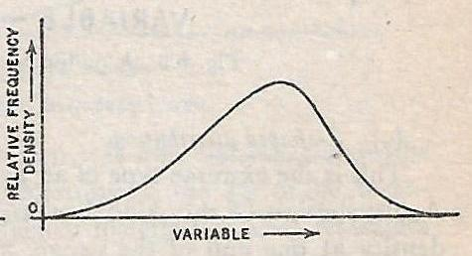

### Fig. 10: Negatively skew frequency curve

### Multimodal distribution

### Have more than one local maximum.

### This type is rarely encountered

### It is indicative of non-homogeneity of the data

### C:\Users\SUSANTA KUMAR GAURI\Desktop\multimodal.jpg

### Fig. 11: Multimodal frequency curve

### J-shaped distribution

### This is the extreme type of an asymmetric frequency distribution.

### Has its highest frequency or frequency-density at one end of the range and it gradually decreases as one moves to the right or to the left (as the case may be)

### Income distribution of earners, age distribution of population etc. are found to closely resemble this form.

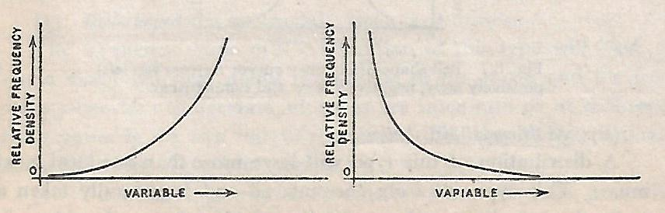

### Fig. 12: J-shaped frequency curve

### U-shaped distribution

### The frequency or frequency-density is lowest for some value at the middle of the range and increases either at the same rate or at different rates as the values of the variable shifts to the left or to the right.

### This is a rare form of distribution.

### Ages of deceased persons in a population follow distribution of this type.

### U shaped.jpg

### Fig. 13: U-shaped frequency curve